Running an Application as Administrator or in Compatibility Mode
Posted on31 March 2011AuthorAlex Verboon10 Comments
Today someone in a forum asked how to programmatically configure an application so that it runs in compatibility mode. Configuring this manually is easy, just open the file’s properties, select the Compatibility tab and apply the required settings. On Windows 7 this then looks as shown in the picture below.
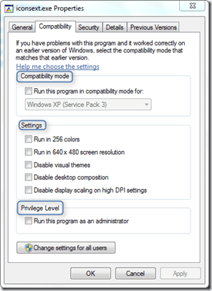
Now whatever we configure here, it all gets written to the following location in the Windows Registry:
HKEY_CURRENT_USER\Software\Microsoft\Windows NT\CurrentVersion\AppCompatFlags\Layers
If the settings have to apply for all users the information must be stored here:
HKEY_LOCAL_MACHINE\Software\Microsoft\Windows NT\CurrentVersion\AppCompatFlags\Layers
When configuring compatibility mode settings for an application executable, shortcut or batch file, a registry string is created for each item.
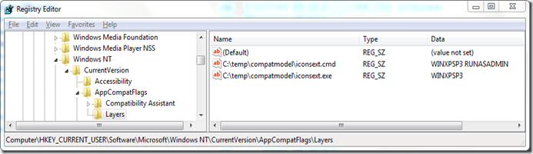
For each application there are three settings that can be applied. The compatibility mode, (Display) Settings and the Privilege Level. One or multiple values can be set (separated by a space).
Compatibility Modes
Value | Description
WIN95 | Windows 95
WIN98 | Windows 98
WIN4SP5 | Windows NT 4.0 SP5
WIN2000 | Windows 2000
WINXPSP2 | Windows XP SP2
WINXPSP3 | Windows XP SP3
VISTARTM | Vista
VISTASP1 | Vista SP1
VISTASP2 | Vista SP2
WIN7RTM | Windows 7
WINSRV03SP1 | Windows Server 2003 SP1
WINSRV08SP1 | Windows Server 2008 SP1

Display Settings
Value | Description
DISABLETHEMES | Disable Visual Themes
640X480 | Run in 640 x 480 screen resolution
HIGHDPIAWARE | Disable display scaling on high DPI settings
256COLOR | Run in 256 colors
DISABLEDWM | Disable Desktop Composition

Privilege Level
Value | Description
RUNASADMIN | Run program as an administrator

If the settings are written into the HKEY_LOCAL_MACHINE part of the registry, the settings cannot be changed by a user that has no local administrative rights.
The following registry command line applies Windows XP SP3 compatibility mode and defines the application to run as administrator.
REG ADD "HKLM\SOFTWARE\Microsoft\Windows NT\CurrentVersion\AppCompatFlags\Layers" /v "C:\temp\compatmodel\iconsext.exe" /t REG_SZ /d "WINXPSP3 RUNASADMIN" /f

